Project 1 Document

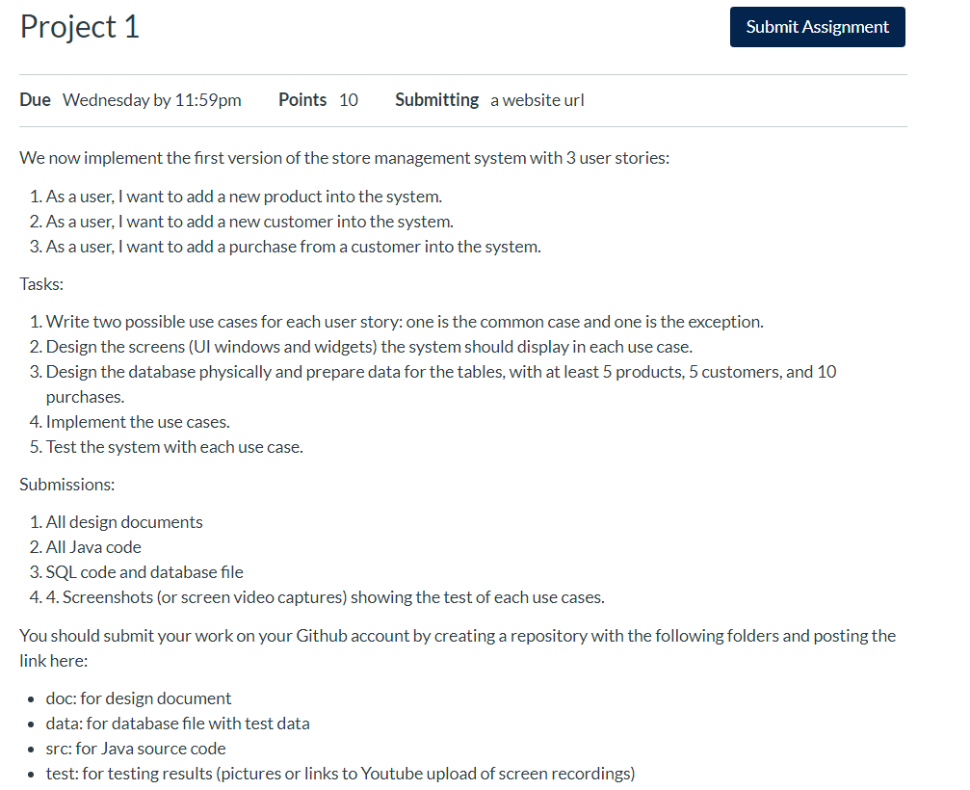

1, 2 & 3) Add new product, customer, and purchase into the system *DONE*

Adding a new product into the system

|  |  |
| --- | --- |
| Actor | System |
| 1. Choose command “Add New Product”    Main Screen: | 2. Display “Add Product” screen  “Add Product” screen: |
| 3. Input data then click “Add” button  “Add Product” screen with data: | 4. Hide “Add Product” screen and display “Add Product Successfully” screen: |
| Click on “OK” button | 6. Display “Main” screen: |

Add a new customer into the system:

|  |  |
| --- | --- |
| Actor | System |
| 1. Choose command “Add New Customer”    Main Screen: | 2. Display “Add Customer” screen  “Add Customer” screen: |
| 3. Input data then click “Add” button  “Add Customer” screen with data: | 4. Hide “Add Customer” screen and display “Add Customer Successfully” screen: |
| Click on “OK” button | 6. Display “Main” screen: |

Add a new Purchase:

|  |  |
| --- | --- |
| Actor | System |
| 1. Choose command “Add New Purchase”    Main Screen: | 2. Display “Add Purchase” screen  “Add Purchase” screen: |
| 3. Input data then click “Add” button  “Add Purchase” screen with data: | 4. Hide “Add Purchase” screen and display “Add Purchase Successfully” screen: |
| Click on “OK” button | 6. Display “Main” screen: |

TASKS:

1. Write two possible use cases for each user story: one is the common case and one is the exception. *DONE*

Common cases:

* 1. Add a new product into the system.
  2. Add a new customer into the system.
  3. Add a purchase from a customer into the system.

Exception cases:

* 1. Cancel adding a new product into the system
  2. Cancel adding a new customer into the system
  3. Producing a receipt from a customer purchase

1. Design the screens (UI windows and widgets) the system should display in each use case.

*DONE ABOVE*

1. Design the database physically and prepare data for the tables, with at least 5 products, 5 customers, and 10 purchases.

5 products)

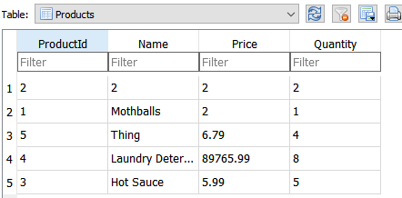

5 customers)

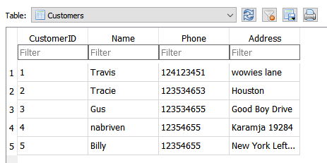

10 purchases)

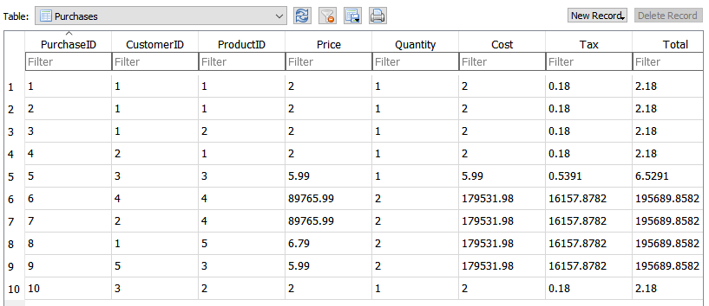

1. Implement the use cases.

Common cases:

* 1. Add a new product into the system.

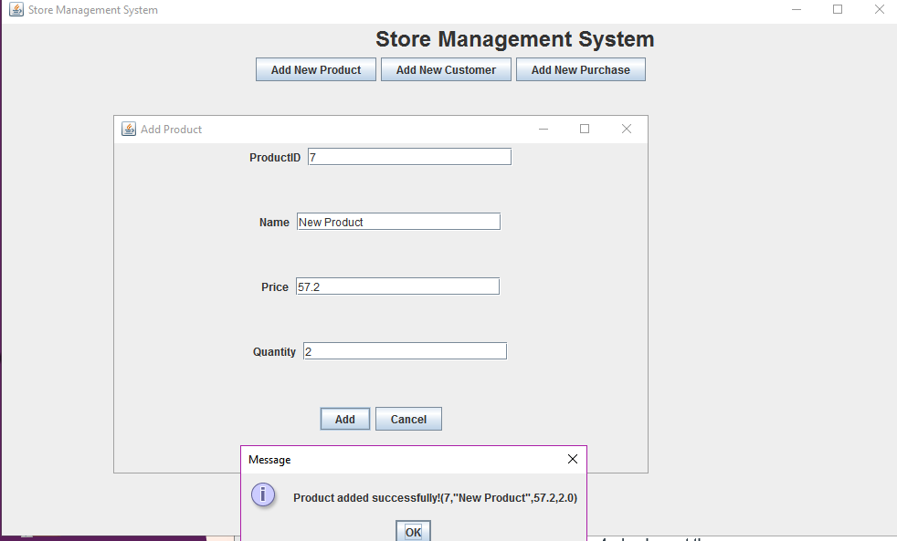

* 1. Add a new customer into the system.

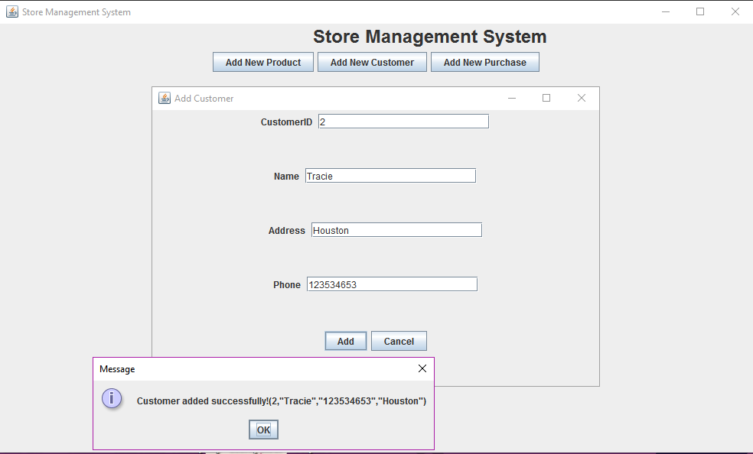

* 1. Add a purchase from a customer into the system.

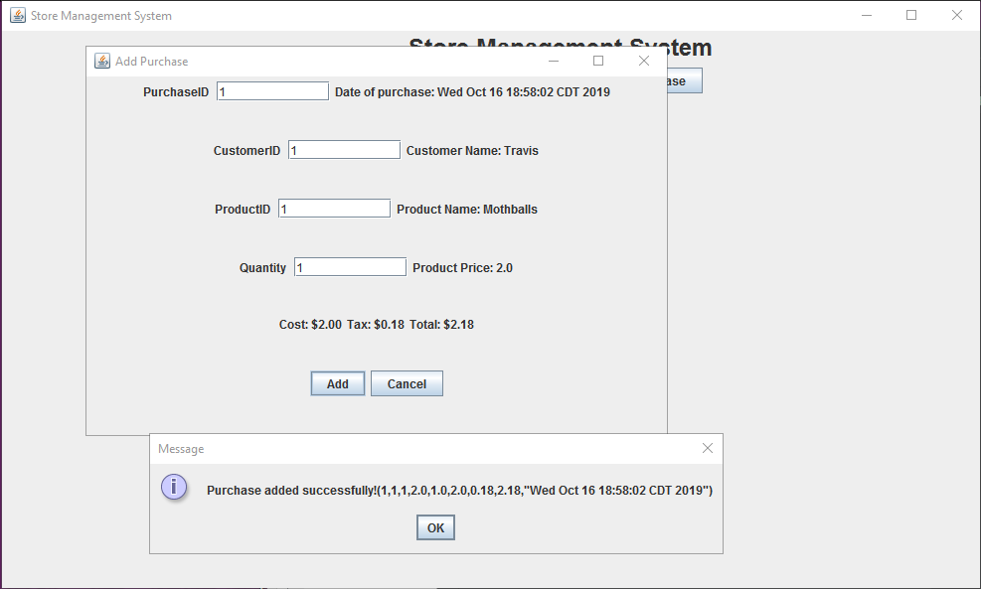

Exception cases:

* 1. Cancel adding a new product into the system

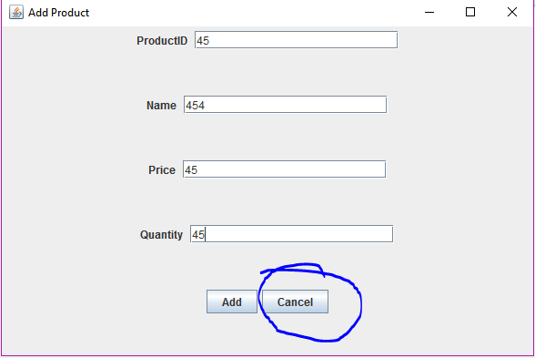

* 1. Cancel adding a new customer into the system

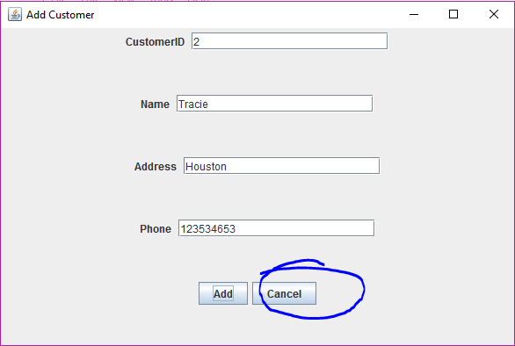

* 1. Producing a receipt from a customer purchase

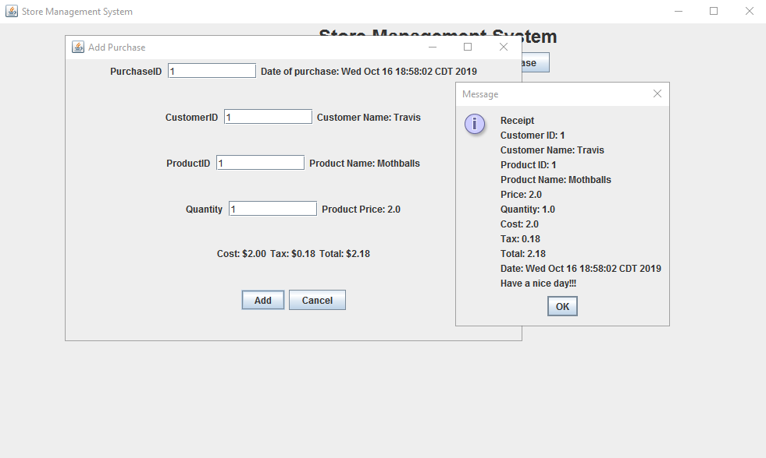

1. Test the system with each use case. *DONE*